Department of Computer Science

COMSATS University Islamabad,

Abbottabad Campus, Pakistan



**CSC371**

**Database Systems 1**

**Hospital Management System**

**Group Members:**

**FA22-BSE-001 Ali (Group Leader)**

**FA22-BSE-001 Ali**

**FA22-BSE-002 Sami**

**FA22-BSE-003 Zain**

Contents

CHAPTER 1 – Mission Statement and Objectives 3

Mission Statement 3

Mission objectives 4

Ali FA20-BSE-001- Branches Module 4

Yasin FA20-BSE-001- Staff and Clients Management 5

CHAPTER 2 – System Definition 6

User Views 6

Examples 6

Major user views for the DreamHome 6

Systems boundary for the DreamHome 8

CHAPTER 3 – Conceptual Database Design 9

ER Diagram 9

EER Diagram 9

CHAPTER 4 – Application Design 10

User Interface 10

User Interface Design Guidelines 10

References with Pros and Cons: 10

# CHAPTER 1 – Mission Statement and Objectives

## Mission Statement

*An important first step in database planning is to clearly define the mission statement for the database system. The mission statement defines the major aims of the database system. Those driving the database project within the organization (such as the Director and/or owner) normally define the mission statement. A mission statement helps to clarify the purpose of the database system and provide a clearer path towards the efficient and effective creation of the required database system. Once the mission statement is defined*

Example (for DreamHome)

The purpose of the DreamHome database systems is to maintain the data that is used and generated to support the property rentals business for our clients and property owners and to facilitate the cooperation and sharing of information between branches.

## Mission objectives

xfsdfsdfs

*Once the mission statement is defined, the next activity involves identifying the mission objectives. Each mission objective should identify a particular task that the database system must support.*

Mission objectives (for DreamHome)

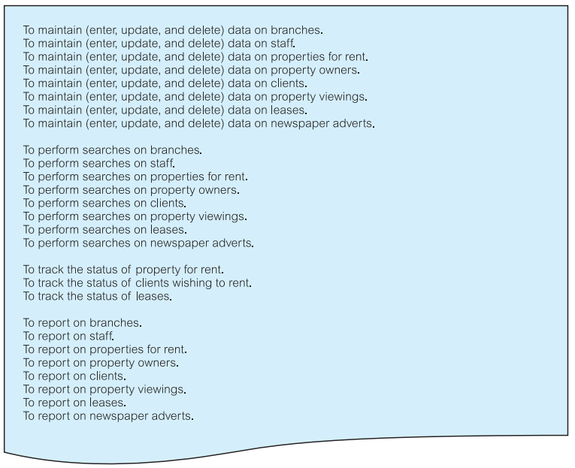

Additionally for your semester project, Every group member will have to explicitly mentioned their identified mission objectives of the assigned module as below:

### Ali FA20-BSE-001- Branches Module

* To maintain (enter, update and delete) data on branches.
* To perform searches on branches.
* To report on branches.

### Yasin FA20-BSE-001- Staff and Clients Management

….

# CHAPTER 2 – System Definition

## User Views

*Defines what is required of a database system from the perspective of a particular job role (such as Manager or Supervisor) or enterprise application area (such as marketing, personnel, or stock control).*

*A database system may have one or more user views. Identifying user views is an important aspect of developing a database system because it helps to ensure that no major users of the database are forgotten when developing the requirements for the new database system.*

*A user view defines what is required of a database system in terms of the data to be held and the transactions to be performed on the data*

*For your semester project you will have to:*

* *Provide the description of major user views (includes job roles or business application areas)*
* *Define the scope and boundary of database application; definition of user views to be supported*

## Examples

### Major user views for the DreamHome

The majority of data about the user views was collected during interviews with the Director and members of staff in the role of Manager, Supervisor, and Assistant.

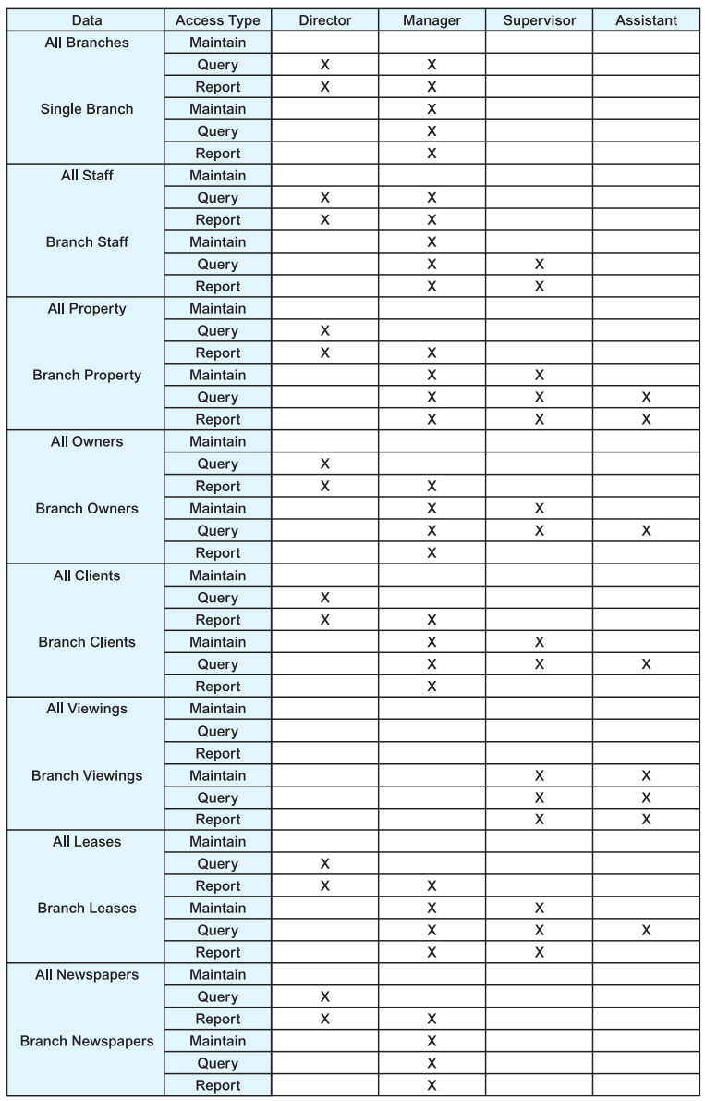

*For further details on each role and respective requirements follow Textbook 10.4.4 section.*

## Systems boundary for the DreamHome

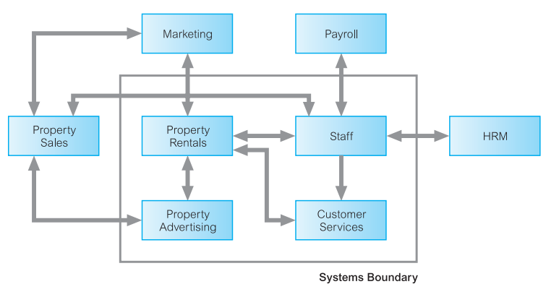

As per above diagram DreamHome will have four major modules:

1. Property Rentals
2. Staff
3. Property Advertising
4. Customer Services

# CHAPTER 3 – Conceptual Database Design

## ER Diagram

Paste the ER Diagram of your semester project here

## EER Diagram

Paste the ER Diagram of your semester project here

# CHAPTER 4 – Application Design

This chapter should cover the prototype of your semester project as per the following section:

## User Interface

Step 1: Familiarize yourself to application designing.

### User Interface Design Guidelines

1. Meaningful title
2. Comprehensible instructions
3. Logical grouping and sequencing of fields
4. Visually appealing layout of the form/report
5. Familiar field labels
6. Consistent terminology and abbreviations
7. Consistent use of color
8. Visible space and boundaries for data-entry fields
9. Convenient cursor movement
10. Error correction for individual characters and entire fields
11. Error messages for unacceptable values
12. Optional fields marked clearly
13. Explanatory messages for fields
14. Completion signal

Step 2: Comparative analysis of user interfaces

In this part you need to find at least five similar systems to your

semester project and comment on good and bad points in their interface designs.

### References with Pros and Cons:

System 1: URL

Pros

Cons:

System 2: URL

….

Step 3: Choose navigational system for your project, such that access of every screen is clear from the home/default screen.

1. Make sure on every screen user knows how to go back to home
2. Make sure he knows the hierarchy of the opening screen i.e. breadcrumbs

Step 3: What information would you like to show to the user on First screen. Every group member will have to contribute the relevant information into the home screen and justify the reason.

**Task** is to give a demo of the Non-Functional Prototype (Based on Viva)

# CHAPTER 5 – Logical Database Design

Identification of General Constraints

To be modified soon …

# CHAPTER 6 – Physical Database Design

## Project SQL Script File - Version 1

Provide a link to your cloud storage .sql script file here, which should do the following:

1. Create Database if not exist
2. Create all tables in your project along with primary and foreign keys
   * Note: Every group member should create their own tables in the file along with registration and name on top in comments
3. Feed Sample data to all tables.
   * Note: Every group member should feed sample realistic data in respective tables in the file along with registration and name on top in comments
4. What was the difficult part in creating this assignment?
   * Every group member should define their own area.
5. Generate information from your table by relating them to tables of other group members as well. You will have to write at least 5 meaningful simple, average and complex queries
   * Every group member should define their own area.

# CHAPTER 7 – Common Reports

* Common Reports